TABLE OF Contents
ABSTRACT 3
ACKNOWLEDGEMENT…………………………………………………………………………………………………………………………….3
CHAPTER 1: INTRODUCTION 4
Organization of the Report 4
CHAPTER 2: SYSTEM ARCHITECTURE AND TECHNOLOGIES USED 6
2.1 System Architecture Overview 6
2.2 Frontend Technologies 7
2.3 Backend Technology 7
2.4 Database 8
CHAPTER:3 CONCEPTUAL DESIGN...................................................................................................8
3.1 Design Methodology 9
Chapter 5: Implementation Design 17
5.1 Database Schema Implementation 17
5.2 Backend Implementation (PHP) 19
5.3 Database Integrity Constraints 19
5.4 Implementation Workflow 20
Chapter 6: Frontend Implementation – Sageline Express 20
6.1 Frontend Design Goals 20
6.2 User Interfaces 20
6.3 Frontend Workflow 21
6.4 Design Features 21
Chapter 7: Database Security Implementation 22
7.1 Security Objectives 22
7.2 Implemented Security Measures 22
7.3 Recommendations for Enhanced Security 23
Future Improvements 23
8.1 Suggested Enhancements 23
8.3 Scalability and Deployment Considerations 24

ACKNOWLEDGMENT
We would like to extend our sincere gratitude to Sir Kashif Asrar, our course instructor, for his unwavering guidance, encouragement, and valuable insights throughout the duration of this project. His expertise in the subject matter and consistent mentorship played a vital role in shaping the scope and direction of our work.
We are also deeply thankful to Sir Muzammil, our practical instructor, whose hands-on approach and technical support were instrumental in implementing and testing the core functionalities of the system. His feedback helped us navigate the practical challenges of database development and backend integration.

ABSTRACT
The Railway Management System project is a web-based application designed to automate and manage the core functions of a railway reservation environment. These functions include user registration, train management, route assignment, seat allocation, ticket booking, and payment recording. The system is developed using MySQL for backend data storage and PHP for backend logic, supported by HTML, CSS and JavaScript on the frontend.
A normalized relational database schema was designed to ensure data consistency and efficient information retrieval. The system architecture reflects real-world requirements by establishing relational links among critical entities such as users, trains, routes, bookings, and payments.
The goal of this project is to demonstrate how database management principles can be effectively applied to build a robust, scalable, and user-friendly system capable of replacing traditional manual processes. The development of this system allowed us to apply theoretical concepts to a practical use case and strengthened our understanding of relational databases and backend web development. Through this project, we gained hands-on experience on practical exposure to real-world database design, which are essential skills for future professional work in the software industry.

CHAPTER 1: INTRODUCTION

Organization of the Report
- Chapter 1 introduces the project, outlines its objectives, and defines the problem domain.
- Chapter 2 covers the system architecture and technologies used.
- Chapter 3 explains the database schema, relationships, and normalization.
- Chapter 4 discusses the functionalities and user workflows.
- Chapter 5 presents testing, results, and validation of the system.
- Chapter 6 concludes the report and proposes future enhancements.

1.1 Overview
In the digital era, automation of large-scale public service systems has become essential for operational efficiency, reliability, and user convenience. One such critical infrastructure is the railway reservation system, which manages thousands of daily bookings, route allocations, and passenger interactions. Manual systems or fragmented software solutions often lead to errors, inefficiencies, and delays. To address these issues, we have developed a Railway Management System and named it SAGELINE EXPRESS a web based application that leverages relational database technology to streamline and automate the core processes of railway services.
The system is designed to manage key modules such as user registration, passenger records, train and route details, seat availability, ticket booking, and payment tracking. Our goal is to simulate a real-world, scalable solution using foundational principles of Database Management Systems (DBMS), implemented using MySQL and PHP, with an interactive frontend built using HTML, CSS and JavaScript.

1.2 Motivation
The manual handling of railway reservations is not only time-consuming but also prone to errors such as overbooking, fare mismanagement, and poor tracking of passenger records. Modern transportation systems demand robust backend structures supported by efficient databases that can ensure consistency, scalability, and security. Our motivation stems from this need to simulate a reliable, structured, and educational model of a railway reservation system using core DBMS concepts and web technologies.
This project not only serves academic learning objectives but also reflects real-world applications that can be extended to larger, production-grade systems in future development.

1.3 Problem Statement
Traditional railway booking and management processes are inefficient and lack integration. Key issues include:
- No centralized user and booking management.
- Inaccurate or duplicate passenger information.
- Difficulty in managing routes, seat availability, and booking history.
- Manual fare assignment without validation tracking.
This project aims to resolve these issues by implementing a fully connected, normalized database that supports all core railway management functionalities through a seamless web interface.

1.4 Objectives
The primary objectives of the Railway Management System are:
- To design and implement a relational database for efficient data handling.
- To facilitate booking and seat allocation processes through automation.
- To provide an interface for administrative users to manage trains, routes, and fares.
- To ensure the consistency and integrity of passenger and payment information.
- To provide modular and extendable functionality suitable for future improvements.

1.5 Scope of the Project
This project simulates the backend and administrative aspects of a railway reservation system. It covers:
- User and passenger profile management.
- Route and station mapping.
- Train scheduling and seat management.
- Booking and ticket generation.
- Manual fare entry per train and class.
- Recording of payment information and travel history.
The current system does not include live tracking, dynamic pricing, or third-party integrations (e.g., SMS/email APIs). However, it is structured to allow future integration of such features.

1.6 Methodology
The project development followed a structured methodology:
- Requirement Analysis: Identification of key modules such as user, train, route, and booking.
- Database Design: ER modeling and normalization to ensure efficient schema development.
- Frontend Development: Use of HTML, CSS, and JavaScript for interface design.
- Backend Integration: PHP scripting to handle user interactions and database communication.
- Testing: Validating inputs, verifying relationships, and ensuring CRUD operations perform as expected.

CHAPTER 2: SYSTEM ARCHITECTURE AND TECHNOLOGIES USED

2.1 System Architecture Overview
The Railway Management System follows a modular, layered architecture, incorporating a client-server model that separates the user interface, application logic, and database management components. This layered structure ensures maintainability, scalability, and ease of integration.
The three primary layers are:
- Presentation Layer (Frontend) – The user-facing interface developed using HTML, CSS and JavaScript.
- Application Layer (Backend) – Handles the business logic and communication between the frontend and the database, developed in PHP.
- Data Layer (Database) – The relational database designed using MySQL, which stores all persistent data including users, bookings, routes, and payments.
System Flow Diagram
User Interface (HTML/CSS/JS)
↓
PHP Backend Logic
↓
MySQL Database
This architecture ensures that each component can be developed, tested, and maintained independently.

2.2 Frontend Technologies

2.2.1 HTML (Hyper Text Markup Language)
HTML forms the structural foundation of the web pages in the system, such as registration forms, login pages, and booking interfaces.

2.2.2 CSS
CSS was used to design and style the user interface, ensuring visual consistency across all pages. We manually applied layouts, colors, fonts, and spacing to achieve a clean and responsive design. This allowed us full control over the appearance without relying on external frameworks.
2.2.3 JavaScript
JavaScript handles basic client-side validations, dynamic interactions, and improves responsiveness without frequent page reloads.

2.3 Backend Technology

2.3.1 PHP (Hypertext Preprocessor)
PHP serves as the middleware between the frontend and the MySQL database. It handles:
- User authentication and session handling.
- Data processing (inserting bookings, managing availability).
- Admin functionalities (train management, route creation, adding new trains and stations).
- Secure database communication via SQL queries.
PHP’s integration with HTML and ease of deployment in XAMPP makes it ideal for this academic project.

2.4 Database

2.4.1 MySQL
MySQL is the core DBMS used for data storage and retrieval. It supports:
- Relational schema with foreign key constraints.
- SQL queries for CRUD operations.
- Transaction integrity.
All entities such as users, trains, routes, bookings, and payments are interconnected via foreign keys, ensuring normalized and consistent data.

2.4.2 phpMyAdmin
Used for database visualization, table creation, query execution, and debugging. phpMyAdmin simplifies backend operations during development and testing.

Chapter 3: Conceptual Design
A well-structured database is the foundation of any efficient information system. For the Railway Management System, a relational database model was selected using MySQL to manage data related to users, trains, stations, routes, bookings, and payments. The database was carefully designed to support data consistency, integrity, and scalability, adhering to standard normalization rules to eliminate redundancy and improve query efficiency.

3.1 Design Methodology
The design process began with the identification of key entities and their attributes based on functional requirements. Relationships among these entities were then established using Entity-Relationship (ER) modeling, followed by schema generation using SQL. Foreign key constraints were implemented to enforce referential integrity across related tables.
ER DIAGRAM
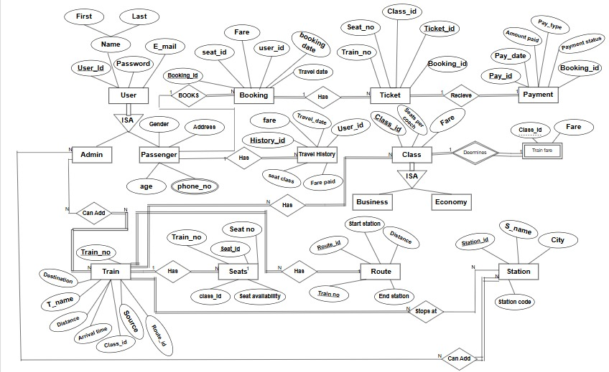
Chapter 4: Logical Design
4.1 Normalization Of Tables
The normalization process for the Railway Management System database.
Normalization is the process of organizing data to reduce redundancy and improve data integrity. The goal is to create a well-structured database that minimizes anomalies during data operations while preserving all original attributes.
Following are tables available in our database:
- Railway_Admin:
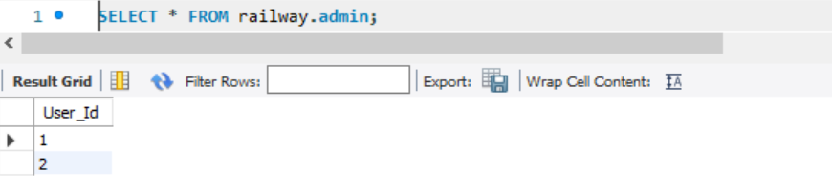
- Booking:
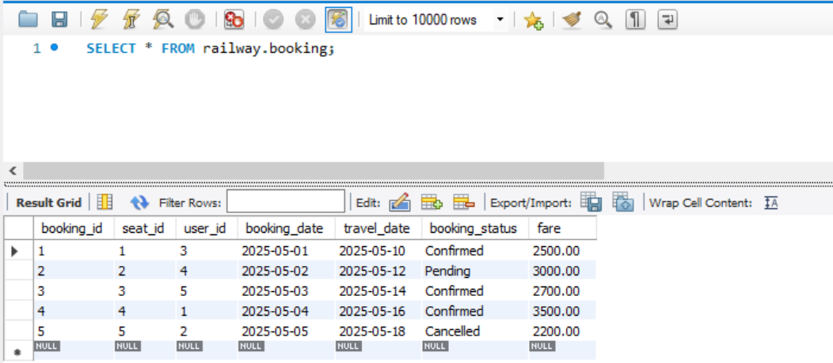

- Class_Details:
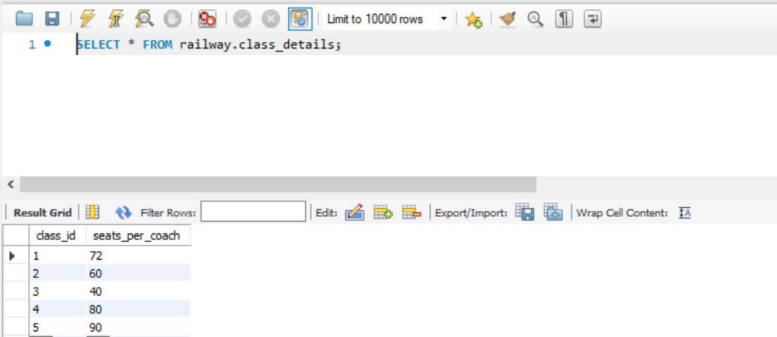
- Route:
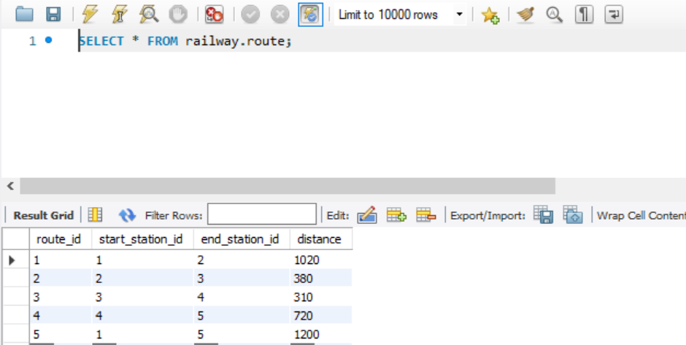

- Station:
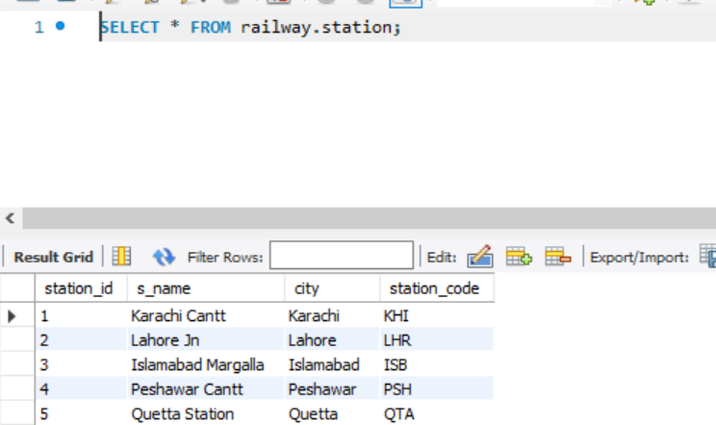

- Train:
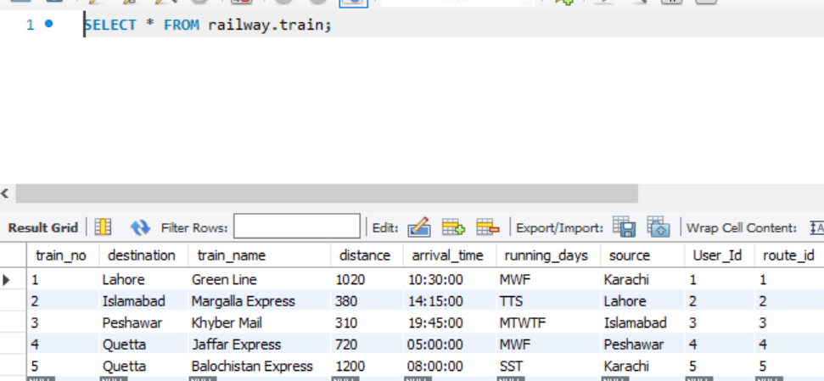
- Train_Fare:
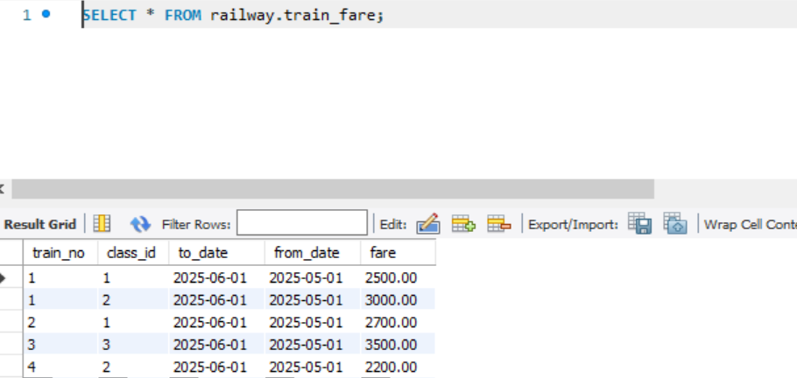
- Train_Route:
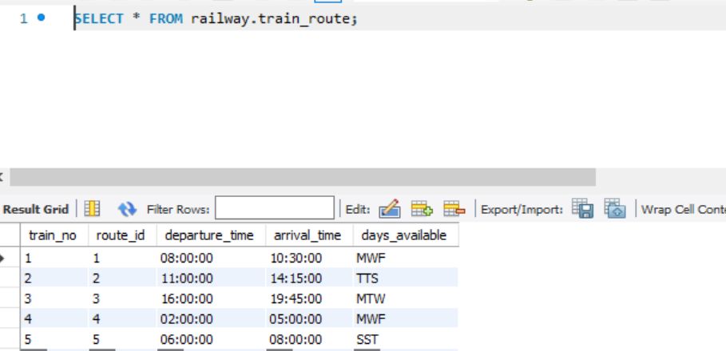
- Travel_History:
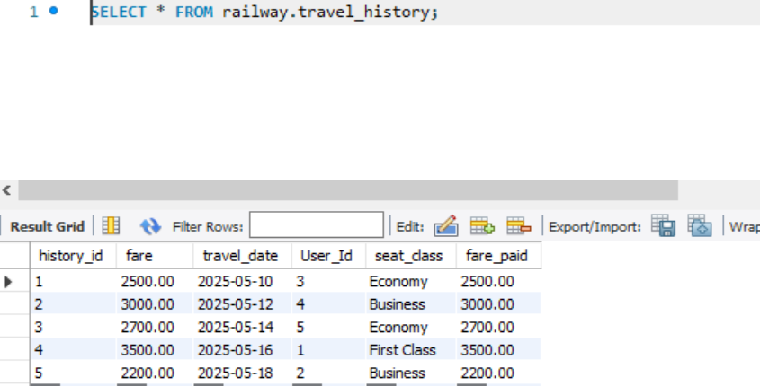

- UserDetails
- User_ID
- First_Name
- Last_Name
- Age
- Gender
- Street
- City
- Zip_Code
- Email
- Password
- Phone_No

NORMALIZATION OF TABLE:

Step 1: Apply First Normal Form (1NF)

In 1NF, we ensure that all fields are atomic (i.e., no multivalued attributes) and every row contains a single piece of information.

Our table contain atomic values so, it is already in 1NF form no changes are required.

Step 2: Apply Second Normal Form (2NF)
In 2NF, we remove partial dependencies. A partial dependency occurs when a non-key attribute depends only on part of a composite primary key.
- Primary key: A composite key (User_ID, Phone_No)
  - Partial dependencies:
    - First_Name, Last_Name, Age, Gender, Street, City, Zip_Code, Email, and Password are dependent only on User_ID.
    - Phone_No depends on the combined key (User_ID, Phone_No).

Solution:
We will split the table into multiple tables:
- user: Store all the user information.
- phonenumber: Store each phone number.
- passenger: Contains user-specific information such as age, gender, etc.

Result after 2NF:

1. Table: user
- User_ID (PK)
- First_Name
- Last_Name
- Email
- Password

2. Table: phonenumber
- Phone_No (PK)
- User_ID (FK)

3. Table: passenger
- User_ID (PK/FK)
- Age
- Gender
- Street
- City
- Zip_Code

Step 3: Third Normal Form (3NF)
In 3NF, we remove transitive dependencies. We check if any non-primary key attributes depend on other non-key attributes.
City and Zip_Code are related, but no transitive dependency on User_ID exists in our case, because they are atomic and don't directly influence each other based on any primary key.
Since there are no transitive dependencies, the structure remains unchanged.
- Another table in our database is Ticket_Allocation. It is also needed to be normalize. It has the following attributes.

- Ticket_Allocation:
- ticket_id
- booking_id
- class_id
- class_name
- seat_id
- seat_no
- seat_availability
- train_no

NORMALIZATION OF TABLE:

Step 1: Apply First Normal Form (1NF)

In 1NF, we ensure that all fields are atomic (i.e., no multivalued attributes) and every row contains a single piece of information.

Our table contain atomic values so; it is already in 1NF form no changes are required.

Step 2: Apply Second Normal Form (2NF)
In 2NF, we remove partial dependencies. A partial dependency occurs when a non-key attribute depends only on part of a composite primary key.
We identify the primary key in this un normalized structure as ticket_id.
In 2NF, booking_id, train_no, seat_no, and class_id depend fully on ticket_id, while class_name depends only on class_id, and seat_availability, seat_no, and class_id depend only on seat_id, making them partial dependencies that must be moved to separate tables.

So, we split them into 3 tables:

1. table ticket:
- ticket_id (PK)
- booking_id (FK)
- train_no (FK)
- class_id (FK)
- seat_no

2. seat:
- seat_id (PK)
- seat_no
- train_no (FK)
- class_id (FK)
- seat_availability

3. seat_class:
- class_id (PK)
- class_name

Step 3: Third Normal Form (3NF)
In 3NF, we remove transitive dependencies. We check if any non-primary key attributes depend on other non-key attributes.
All non-key attributes in ticket, seat, and seat_class depend entirely on their respective primary keys with no transitive dependencies, confirming all three tables are in 3NF. No changes required.

Chapter 5: Implementation Design
The implementation of the Sageline Express Railway Management System followed a structured development approach starting with the relational database schema, followed by backend scripting and finally frontend integration. This chapter describes the core design and implementation details of the system with respect to its database architecture, backend logic, and modular development workflow. The system was implemented using MySQL for the database and PHP for server-side scripting, with user interaction handled through HTML, CSS, JavaScript.

5.1 Database Schema Implementation
The system uses MySQL to create a well-normalized and relational schema with clearly defined primary, foreign, and composite keys. Below is a breakdown of how the implementation reflects the schema:

5.1.1 User Table

Stores credentials and basic details for all system users.
- User_Id : Primary Key.
- E_mail : Unique identifier for login.
- Supports multiple roles via references in admin and passenger tables.

5.1.2 Admin Table

Maps users with administrative privileges.
- User_Id : Foreign Key referencing user.

5.1.3 Passenger Table

Extends the user table with demographic information.
- User_Id : Primary Key and FK referencing user.
- Attributes include Age, Gender, City, Street, Zip_Code.

5.1.4 PhoneNumber Table

Stores contact numbers (supports multiple per user).
- Composite Primary Key: Phone_No, User_Id.

5.1.5 Station and Route Tables

Define station information and inter-station connectivity.
- station: station_id (PK), s_name, city, station_code.
- route: route_id (PK), connects start_station_id and end_station_id, includes distance.

5.1.6 Train Table

Holds train metadata and connectivity.
- train_no : Primary Key
- Includes train_name, source, destination, arrival_time, route_id (FK)

5.1.7 Class Management
- class_details: class_id (PK), seats_per_coach
- seat_class: class_id (PK), class_name

5.1.8 Seats Table

Handles seat allocation and availability.
- seat_id : Primary Key
- Attributes: seat_no, seat_availability, train_no (FK), class_id (FK)

5.1.9 Booking Table

Captures travel reservations.
- booking_id : Primary Key
- Includes booking_date, travel_date, fare, seat_id (FK), user_id (FK)

5.1.10 Ticket Table

Generates a ticket for each successful booking.
- ticket_id : Primary Key
- Attributes: seat_no, train_no, class_id, booking_id (FK)

5.1.11 Payment Table

Records transactions linked to bookings.
- pay_id : Primary Key
- Attributes: pay_type, payment_status, amount_paid, pay_date
- Linked to booking_id and train_no via Foreign Keys

5.1.12 Train Fare Table

Stores static fare entries defined by admin.
- Composite Key: train_no, class_id
- Attribute: fare

5.1.13 Travel History Table

Stores journey logs per user.
- history_id : Primary Key
- Includes: travel_date, fare, fare_paid, seat_class, user_id (FK)

5.2 Backend Implementation (PHP)
The backend logic is written in PHP and facilitates:
- User Authentication: Registration and login using user table.
- Passenger Data Handling: Inserts into passenger table after sign-up.
- Booking Logic: On seat selection, PHP scripts validate availability, generate a new booking_id, and store details.
- Admin Controls: Custom pages to add/update train, route, fare, station.
- Ticket Generation: After successful booking and payment, a unique ticket_id is created.
- Payment Processing: PHP forms insert transaction details into payment table and update booking status.
Backend scripts follow a modular naming convention like:
- register.php, login.php
- add_train.php, manage_routes.php
- book_ticket.php, payment.php

5.3 Database Integrity Constraints
To ensure reliable operation:
- Primary Keys uniquely identify each record.
- Foreign Keys enforce referential integrity across tables.
- Composite Keys (e.g., in train_fare) enforce valid combinations of data.
- Nullable fields allow flexibility where appropriate (e.g., optional payment date).
- Unique Constraints prevent duplicate email addresses and train numbers.

5.4 Implementation Workflow
- Database Creation
  - Tables created in phpMyAdmin as per the normalized schema.
  - Sample records inserted for testing stations, trains, classes, and fares.
- User Interface Development
  - HTML forms designed for login, booking, admin panels.
  - Forms submit data to PHP scripts which process logic and interact with MySQL.
- Session Management
  - PHP sessions used to maintain user state post-login.
  - Role-based redirection implemented for admin and passengers.
- Booking and Ticketing Flow
  - Seat selected → Booking created → Fare verified → Payment made → Ticket issued.
- Admin Operations
  - Admin can add/update trains (set fares, assign classes) also add station, route.

Chapter 6: Frontend Implementation – Sageline Express

6.1 Frontend Design Goals
- User-Friendly Interface: Simple navigation, clear forms, and actionable buttons.
- Modular Design: Separate interfaces for passengers and admins.

6.2 User Interfaces

6.2.1 Home Page
- Displays project title “Sagline Express”.
- The user can register, login, view trains and see the about us options on the side bar.
- Two primary actions: Passenger Login/Register and Admin Login.

6.2.2 Registration & Login
- Passenger Registration Form captures name, email, password, zip code, city etc.
- Login Page redirects users based on role (passenger/admin).
- Validation messages for incorrect or empty inputs.

6.2.3 Train Search & Booking
- Dropdowns for source, destination, travel date, and class.
- Results displayed in the form of table showing train details.
- Booking form posts data to backend script to generate a booking.

6.2.4 Admin Dashboard
- Accessible only after admin login.
- Features:
  - Add new train/station/route/class.
  - Can also maintaining fares and class availability in add train form.

6.2.5 Payment Page
- Displays total fare manually defined in the system
- Selectable payment type (e.g., Mobile Banking, Card)
- Confirmation posts data to backend for payment recording

6.2.6 Ticket Display & Travel History
- Generates ticket view with:
  - Seat number
  - Train and class
  - Booking ID and status
- Passenger history table showing previous journeys and fare details

6.3 Frontend Workflow
- User enters input via form (e.g., registration, booking).
- Form action sends input to corresponding PHP script via POST.
- Server processes data and returns updated view or success/error message.
- JavaScript handles dynamic input checks and form feedback.

6.4 Design Features
- Forms: Consistent design using inputs and buttons.
- Tables: Used for booking data, train listings, and history.
- Buttons: Clear labels for actions like "Book Now", "Pay", "Logout".
- Navigation Bar: Simple links for switching between modules.

Chapter 7: Database Security Implementation

7.1 Security Objectives
- Prevent unauthorized access to the database.
- Safeguard sensitive user information such as login credentials.
- Ensure secure communication between frontend and backend.
- Maintain integrity of booking, payment, and administrative records.

7.2 Implemented Security Measures

7.2.1 Authentication and Access Control
- Users must log in using a valid email and password before accessing the system.
- The application differentiates between admin and passenger roles via the admin and passenger tables.
- Role-based redirection ensures that each user only accesses authorized sections of the system.

7.2.2 Password Protection
- User passwords are stored using hashing techniques such as MD5() or password_hash() in PHP.
- Plaintext passwords are never stored or transmitted, ensuring protection even in case of data leaks.

7.2.3 Input Validation and Sanitization
- Server-side validation in PHP filters and sanitizes all user inputs before interacting with the database.
- This prevents SQL injection attacks and ensures query safety.
- Client side validation using JavaScript complements this for user experience.

7.2.4 Foreign Key Constraints
- MySQL foreign key constraints enforce referential integrity, preventing invalid or orphaned records (e.g., bookings linked to non-existent users).

7.2.5 Session Management
- User sessions are securely maintained using PHP sessions ($_SESSION) to prevent unauthorized access once a user is authenticated.
- Session timeouts or manual logouts can be implemented to improve session control.

7.2.6 Error Handling
- Sensitive system errors and SQL messages are not displayed to end users.
- All errors are logged internally for debugging without exposing vulnerabilities.

7.3 Recommendations for Enhanced Security
- Use prepared statements (PDO or MySQLi) instead of raw SQL queries to eliminate SQL injection risk.
- Implement SSL/TLS encryption for secure communication (especially important in live deployments).
- Add CAPTCHA to registration and login pages to prevent bot-based attacks.
- Introduce password strength validation and optional two-factor authentication (2FA).

Future Improvements

8.1 Suggested Enhancements

8.1.1 Dynamic Fare Calculation
- Introduce distance-based or time-based fare calculation instead of fixed manual entries.
- Use formulas or predefined rules based on class, distance, and travel date.

8.1.2 Online Payment Gateway Integration
- Integrate with real-world payment APIs such as Razorpay, PayPal, or Stripe.
- Enable secure online payments via debit/credit cards, or net banking.

8.1.3 Live Train Tracking
- Integrate with third-party APIs to display real-time train locations and delays.
- Useful for passengers to track arrival/departure dynamically.

8.1.4 Email/SMS Notifications
- Notify users via email or SMS after successful bookings or cancellations.
- Send reminders for upcoming travel.

8.1.7 Mobile Application Support
- Develop a cross-platform mobile app using Flutter or React Native.
- Increase accessibility and ease of use for passengers.

8.1.8 Enhanced UI/UX
- Implement more interactive features using modern frontend frameworks such as Vue.js, React, or Angular.
- Improve usability with animations, tooltips, and dynamic form elements.

8.3 Scalability and Deployment Considerations
- Move from a local XAMPP setup to a cloud hosted deployment using platforms like AWS, or Azure.
- Use containerization (Docker) for better deployment consistency.
- Implement more database backup and recovery mechanisms for more reliability.

CONTRIBUTIONS:

1. Shafia Arif (CS-23107):
- Research on Entity-Relationship (ER) diagrams to design a normalized and logically structured database.
- backend development using PHP and MySQL.
- Managed the integration of frontend with backend, ensuring seamless data flow between the user interface and the database.

2. Sania Shakeel (CS-23108):
- Assisted in ER diagram research and design to design a normalized and logically structured database.
- Normalization of tables, ensuring the database adheres to the Third Normal Form (3NF) for data integrity and efficiency.
- Helped in integration and contributed to data insertion in database.

3. Humna (CS-23120):
- Assisted in ER diagram development
- Frontend development using HTML, CSS, JAVASCRIPT.
- Contributed data insertion in database.

